Easy XML, JSON and WebServices

Table of Contents

1. General Information 3
1.1 Benefits of using the framework 3
2. System Summary 4
3. Design Assumptions, Requirements and Constraints 4
4. Getting Started 5
4.1 Extend the EasySOARequest Class 6
4.2 Make Web Service Invocation 7
4.3 Retrieve Data Out of Response 7
4.3.1. Simple Response 7
4.3.2. Collections in Response 9
4.3.3. Receive Error Message 12
4.3.4. Development Assistant Method 12
4.4 Develop Test Cases 13
5. Considerations and Best Practices 14
Appendix: developmental steps to consume web services 16

General Information

This document describes the design of the “Easy XML, JSON and Web Services” framework built in the APEX programming language on the Force.com platform. The framework is distributed as a managed package on the AppExchange portal on Salesforce.com. This document also serves as the user manual providing developers with enough information to configure the framework and to invoke its methods.
The framework started from a work around to overcome technical constraints in the WSDL-To-Apex utility. This utility is a developmental tool taking a WSDL file and then generating Apex stubs to call out to a SOAP-based web service residing out of an SFDC ORG; unfortunately the tool has limits.
- The WSDL document may not exceed the size of 1MB. If it does, developers have to remove any unnecessary methods and/or data types from the WSDL to reduce its size.
- The WSDL file can’t use “xsd:import” to refer to schema definitions from other XSD files. In some cases, developers would have to merge all xsd files into the WSDL, which may in turn cause it to exceed the size limit.
- If the WSDL file includes multiple namespaces in “xsd:extension” hierarchy, runtime exceptions will be thrown from generated stub classes when parsing SOAP responses.
- Sometime auto-generated Apex class may exceed the 1MB size (a governor limit on Apex class.) In this case, WSDL-To-Apex will generate the code and display the code in the salesforce.com user interface along with the appropriate error message. However, the code can’t be saved.
Each of these limits could cause time- or labor-consuming activities to “flatten” existing WSDL in order to successfully generate stub classes. To avoid those pitfalls, the “Easy XML, JSON and Webservices” framework took a different approach and focused on the actual payload in request and respond. It doesn’t require importing any WSDL or other XSD documents at development time and runtime. Instead, the out-of-box generic parsers are able to parse any valid XML streams, and its API methods allow developers to easily retrieve data using XPath strings.
Later, a JSON parser was added and a strategy design pattern was implemented so that the framework is capable of processing web service responses in the SOAP, Restful or JSON formats. It automatically chooses an appropriate parser based on the “Content-type” HTTP header associated to responses at run time. Developers don’t have to spend time on developing boilerplate code to handle HTTP remote invocation and data parsing, and can use the same set of APIs to retrieve data regardless of response’s format.

Benefits of using the framework

- The framework enables developers to implement single pattern when building callout modules regardless of different web service styles and messaging formats.
- The framework reduces overall development effort and coding complexity by handling parsing logic and exceptional situations.
- The framework allows developer to alter pre-configured processing rules on the fly without code change.
- The framework helps to overcome technical constraints in the WSDL-To-Apex tool.

System Summary

The package consists of APEX classes, their unit test cases, and the required custom settings. The class diagram in this section depicts APEX classes and their public methods.
The EasySOARequest is an abstract class. It makes the actual callouts and handles communication or timeout exceptions, if happen. Developer needs to create a subclass per service URL.
The EasySOAResponse class implements the strategy design pattern, which makes itself to select appropriate parser for SOAP, RESTful or JSON message at run time. This class provides a set of XPath-based APIs to retrieve raw data.
The EasyXML and EasyJSON classes handle actual data parsing, storing and retrieving logic. Each of them can be independently used as helper class to process XML or JSON streams.
All the classes named as “TestXXX” are unit test classes. Currently, the framework code is 95% covered by these harnesses.

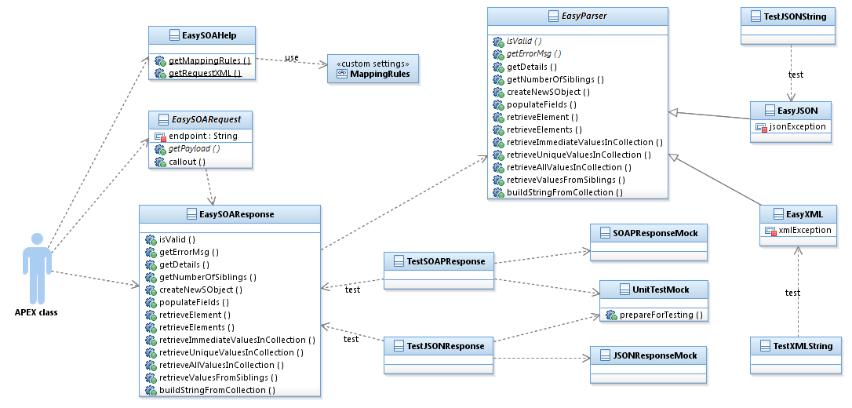

Design Assumptions, Requirements and Constraints

The framework doesn’t require developers to run WSDL-To-Apex to generate web service stub classes for SOAP-based endpoint, nor to create custom parser classes for RESTful or JSON services. To fully leverage the framework, developers should understand basic concepts of web services, XML and JSON. They must also have good understanding on the data structure in responding messages, as well as the mapping rules between xml elements and SObject fields.
Built upon the Froce.com platform, this framework inherited some governor limits on Apex.
- Maximum timeout of callout in a transaction is 120 seconds
- Maximum size of callout request or response is 3MB
- Total number of callouts in a transaction is 10
Before the framework can call an external site, that site must be registered in the Remote Site Settings page, or the call will fail.

Getting Started

After installing the managed package, you will find two new custom settings and two new SObjects. They are shipped as part of the package for testing purposes and have a special namespace “LVT”.
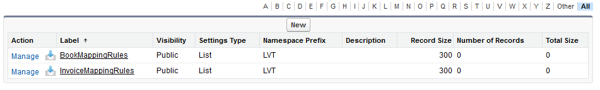

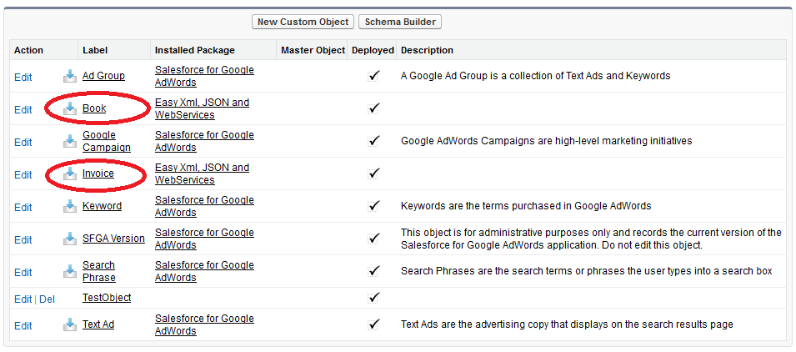

You will also find more classes have been imported into your SFDC ORG. All of them have a special namespace prefix “LVT”.

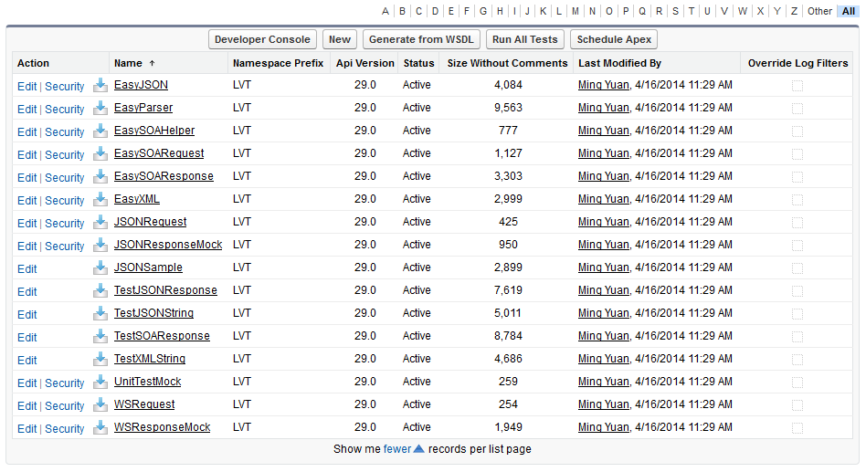
In the “Apex Classes” page, click the “Run All Tests” button and check the test execution results.
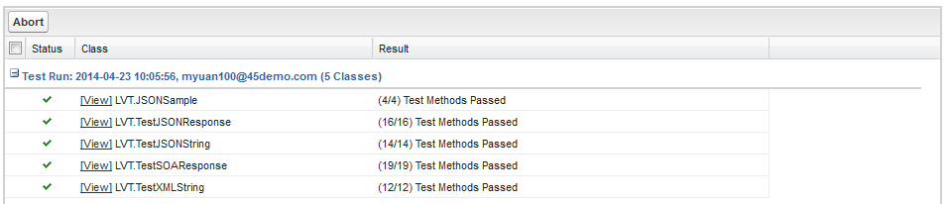
You are now ready to start the development to consume web services.

Extend the EasySOARequest Class

For each external web service endpoint (URL), the framework requires to create a new APEX class by extending the EasySOARequest class in the framework. The “callout” method in the base class will make the invocation and handle exceptions, if any, during the invocation.
- In the constructor of your new class, you must initialize one string-type attribute inherited from the EasySOARequest class – “endpoint”. The value is the URL of the web service end point.
Note: it is recommended to leverage custom settings to store these endpoint URLs.
- You must implement an abstract method – “getPayload”. This method returns a string which is the actual payload in the HTTP request to a service endpoint. The framework doesn’t have any restriction on the approach to implement this method. You can use Apex XML API or String manipulation to generate the string. You can also implement additional setter methods in order to pass in data into this class.
When you invoke a Restful or JSON service endpoints which doesn’t require request, simply return a null.

public class MyWSRequest extends LVT.EasySOARequest {
private String myValue = ‘’;

public MyWSRequest () {
super();
endpoint = ‘http://myservice.oneplace.com’;
httpMethod = ‘POST’; // optional. By default, “GET” will be used.
}

public override String getPayload() {
return ‘<env:Envelope xmlns:xsi="http://www.w3.org/2001/XMLSchema-instance"
xmlns:xsd="http://www.w3.org/2001/XMLSchema"
xmlns:env=”http://schemas.xmlsoap.org/soap/envelope/”>
<env:Body>
<requestdetail>’ +
myValue +
‘</requestdetail>
<env:Body>
</env:Envelope>’;
}

public void setMyValue(String s) {
myValue = s;
}
}

Make Web Service Invocation

Once the request class is ready, you can invoke the web service from triggers or other APEX classes. The steps include:
- Create a new instance of the request class.
- Supplement request data so that your “getPayload” can generate a valid payload.
- Invoke web service by calling the “callout” method. This method associates the output from the “getPayload” to an HTTPRequest, and returns an “EasySOAResponse” object.
- Use the “isValid” method in the EasySOAResponse to validate if the invocation was successful.
If the “isValid” method returns true, you can continue to pull out data from the EasySOAResponse object.

public class MyWSInvoker {

public void invokeWS() {
MyWSRequest req = new MyWSRequest();
req.setMyValue(‘My Real Value’);

LVT.EasySOAResponse resp = req.callout(true); // pass in ‘false’ for JSON

if (!resp.isValid()) {
resp.getErrorMsg(); // And your code to handle exceptions
return;
}

// your code to process data returned
}
}

Note: The EasySOAResponse object would parse raw response only when its “isValid” method is called.

Retrieve Data Out of Response

After the “isValid” method returns true, you can use a set of methods on the EasySOAResponse class to retrieve data. Different methods are available to process responses with or without collection elements.

Simple Response

For any response without any collection element, you can use XPath strings to locate elements while retrieving their values back.
Below is a sample XML to showcase how to use these methods. Although it is showing a RESTful response, you can apply the same logic when working with SOAP-based response.

<root>
<firstbook>
<title>APEX Developer Guide</title>
<price>10</price>
<publishdate>2010-03-01 11:30:00</publishdate>
<instock>true</instock>
</firstbook>
<secondbook>
<title>VisualForce Developer Guide</title>
<price>20</price>
</secondbook>
</root>

- Method: String retrieveElement(String xpath)
This method returns the value of the element to which the xpath parameter points. In the XML example, if you pass in “/root/firstbook/title”, it returns a string – “APEX Developer Guide”.

- Method: Map<String, String> retrieveElements(List<String> xpaths)
This method allows you to retrieve all values from multiple elements in one call. The xpaths list points to these elements. Each item in the list will be used as a key in the returned Map object, where the values come from real response.
In the XML example, if you pass in a string list including “/root/firstbook/title” and “/root/secondbook/title”, the method returns a Map object --

Key | Value
“/root/firstbook/title” | “APEX Developer Guide”
“/root/secondbook/title” | “VisualForce Developer Guide”

- Method: Boolean populateFields(SObject s, Map<String, String> mappings)
This is a convenient method to populate fields in a SObject (standard or custom) from a XML stream. The SObject, in the parameter list, is the object with attributes to be initialized. These attributes will be populated based on their data type. Currently, Text (String), Number, Datetime (in the YYYY-MM-DD HH:MM:SS format), Date (in the YYYY-MM-DD format), and CheckBox (Boolean) are supported.
The Map defines the mappings between the attributes and the XML elements.
In the XML example, if a custom SObject called “book” has the following attributes –
- Title__c: Text
- Price__c: Number
- PublishDate__c: Datetime
- IsInstock__c: CheckBox (Boolean)
Then you can pass in a new Book object and the map below to get the filed in the Book populated.

Key | Value
“Title__c” | “/root/firstbook/title”
“Price__c” | “/root/firstbook/price”
“PublishDate__c” | “/root/firstbook/publishdate”
“IsInstock__c” | “/root/firstbook/instock”

If an error happened during type conversion, this method throws back a System.TypeException to its calling class.

- Method: Boolean populateFields(SObject s, Map<String, String> mappings, List<String> defaults)
This is a convenient method to populate fields in a SObject (standard or custom) either with the value from a XML stream or with default values (empty string, False, or NULL reference).
Similar to the previous method, the Map parameter holds the mapping rules between SObject attributes and XML elements. The defaults list parameter contains a list of SObject attribute to be assigned with default values.
If an error happened during type conversion, this method throws back a System.TypeException to its calling class.

- Method: SObject createNewSObject(String name, Map<String, String> mappings)
This method functions similarly to the populateFields (SObject s, Map<String, String> mappings). The only difference is that this method creates and returns a new SObject instance based on the name parameter.
If an error happened during type conversion, this method throws back a System.TypeException to its calling class.

- Method: SObject createNewSObject(String name, Map<String, String> mappings, List<String> defaults)
This method functions similarly to the populateFields (SObject s, Map<String, String> mappings, List<String> defaults). The only difference is that this method creates and returns a new SObject instance based on the name parameter.
If an error happened during type conversion, this method throws back a System.TypeException to its calling class.

Collections in Response

The EasySOAResponse class provides methods to easily handle multi-level multi-occurrence collection data structure. In order to precisely locate one element in this scenario, these methods normally require two strings – an XPath and an IndexPath. The IndexPath indicates an element in a collection. It always starts with 0 and increments 1 each time when looping through the collection.

<root>
<books>
<book>
<title>Introduction to SaleForce</title>
<price>10</price>
</book>
<book>
<title>APEX Developer Guide</title>
<price>20</price>
<available>
<language>English</language>
<language>Spanish</language>
<language>Chinese</language>
</available>
<publisher>
<name>salesforce.com</name>
</publisher>
</book>
<book>
<title>VisualForce Developer Guide</title>
<price>30</price>
<available>
<language>English</language>
<language>Spanish</language>
</available>
</book>
</books>
</root>

In the sample XML above, the “books” element contains three “book” elements. The second and third “book” contains “available” collections. The table below shows how to use the combination of these two paths to locate an element.

XPath | IndexPath | Value
“/root/books/book/title” | “/0/0/1/0” | “APEX Developer Guide”
“/root/books/book/title” | “/0/0/2/0” | “VisualForce Developer Guide”
“/root/books/book/available/language” | “/0/0/1/1” | “Spanish”

- Method: Integer getNumberOfSiblings(String XPath, String IndexPath)
This method locates one XML element in a collection and returns the total number of the sibling elements in the same collection. For the sample XML above in this section, if you call getNumberOfSiblings(‘/root/books/book/available/language’, ’/0/0/1/1/0’), it returns 3. When you need to retrieve data from each of the elements in a collection, you can use this method to get the total number and then loop through each member.
In case, the numbers of tokens between the XPath and IndexPath string don’t match, this method returns “-1”.

- Method: Map<String, String> retrieveImmediateValuesInCollection(String XPath, String IndexPath)
This method locates one XML element and returns its non-repeated immediate child elements. For the sample XML above in this section, if you call retrieveImmediateValuesInCollection (‘/root/books/book’, ’/0/0/1’), it returns a map containing

Key | Value
“/title” | “APEX Developer Guide”
“/price” | “20”

- Method: Map<String, String> retrieveUniqueValuesInCollection(String XPath, String IndexPath)
This method locates one XML element and returns it’s all non-repeated child elements. For the sample XML above in this section, if you call retrieveUniqueValuesInCollection (‘/root/books/book’, ’/0/0/1’), it returns a map containing

Key | Value
“/title” | “APEX Developer Guide”
“/price” | “20”
“/publisher/name” | “salesforce.com”

- Method: Map<String, String> retrieveAllValuesInCollection(String XPath, String IndexPath)
This method locates one XML element and returns its all child elements. For the sample XML above in this section, if you call retrieveAllValuesInCollection (‘/root/books/book’, ’/0/0/1’), it returns a map containing

Key | Value
“/title” | “APEX Developer Guide”
“/price” | “20”
“/available/language” | “English”
“/available/language__1” | “Spanish”
“/available/language__2” | “Chinese”
“/publisher/name” | “salesforce.com”

- Method: List<String> retrieveValuesFromSiblings(String XPath, String IndexPath)
This method locates one XML element and returns the values of its all sibling elements. For the sample XML above in this section, if you call retrieveValuesFromSiblings (‘/root/books/book/available/language’, ’/0/0/1/0/1’), it returns a list object containing three items – “English”, “Spanish”, and “Chinese”.

- Method: List<String> buildStringFromCollection(String XPath, String IndexPath, String delimiter)
This method locates one XML element and returns the values of its all sibling elements as a single String. For the sample XML above in this section, if you call retrieveValuesFromSiblings (‘/root/books/book/available/language’, ’/0/0/1/0/1’, ’:’), it returns a String – “English:Spanish:Chinese”.

Receive Error Message

In the case that the “isValid” method returns false to indicate error condition, the EasySOAResponse class provides two methods to retrieve error message.
- Method: String getErrorMsg()
This method returns an error message only when exception occurred during callout or data parsing; otherwise, it returns an empty string.

- Method: String getErrorMsg(String XPath)
If any exception has occurred during callout or data parsing, this method returns an error message based on the exception. Otherwise, this method returns the value of the element where the Xpath points. For example, you can invoke getErrorMsg(‘/Envelop/Body/Fault/faultstring’) to get the message of SOAP Fault. This method returns an empty string, if no error condition happened.

Development Assistant Method

EasySOAResponse, EasyXML and EasyJSON classes include a method “getDetails” for debugging purposes. During development phase, developers can invoke this method, after calling the “isValid” method, to see how both XPath and IndexPath are used to point to actual values. The method returns a string. The result generated from the sample XML looks like --

***************** name/value pairs ****************************

/root/books/book/price --> 10
/root/books/book/title --> Introduction to SaleForce
/root/books/book/available/language [/0/0/1/0/0] --> English
/root/books/book/available/language [/0/0/1/0/1] --> Spanish
/root/books/book/available/language [/0/0/1/0/2] --> Chinese
/root/books/book/price [/0/0/1/0] --> 20
/root/books/book/publisher/name [/0/0/1/0/0] --> salesforce.com
/root/books/book/title [/0/0/1/0] --> APEX Developer Guide
/root/books/book/available/language [/0/0/2/0/0] --> English
/root/books/book/available/language [/0/0/2/0/1] --> Spanish
/root/books/book/price [/0/0/2/0] --> 30
/root/books/book/title [/0/0/2/0] --> VisualForce Developer Guide
/root/firstbook/instock --> true
/root/firstbook/price --> 10
/root/firstbook/publishdate --> 2010-03-01 11:30:00
/root/firstbook/title --> APEX Developer Guide
/root/secondbook/price --> 20
/root/secondbook/title --> VisualForce Developer Guide

***************** number of occurrence ****************************

/root --> 1
/root/books --> 1
/root/books/book --> 3
/root/books/book/price --> 1
/root/books/book/title --> 1
/root/books/book/available [/0/0/1/0] --> 1
/root/books/book/available/language [/0/0/1/0/0] --> 3
/root/books/book/price [/0/0/1/0] --> 1
/root/books/book/publisher [/0/0/1/0] --> 1
/root/books/book/publisher/name [/0/0/1/0/0] --> 1
/root/books/book/title [/0/0/1/0] --> 1
/root/books/book/available [/0/0/2/0] --> 1
/root/books/book/available/language [/0/0/2/0/0] --> 2
/root/books/book/price [/0/0/2/0] --> 1
/root/books/book/title [/0/0/2/0] --> 1
/root/firstbook --> 1
/root/firstbook/instock --> 1
/root/firstbook/price --> 1
/root/firstbook/publishdate --> 1
/root/firstbook/title --> 1
/root/secondbook --> 1
/root/secondbook/price --> 1
/root/secondbook/title --> 1

*********************************************

Develop Test Cases

Since the code that performs the callout is in the managed package, the Force.com platform requires calling Test.setMock from a test method in the same package with the same namespace to mock the callout. This package provides developers a helper class to set up mock responses in order to complete test cases.
If you have a mock class (MyMockResponse) implementing the HttpCalloutMock interface, you can set it up as listed below.
static testMethod void myTestMethod() {

// instead of calling Test.setMock, call the line below
new LVT.UnitTestMock(new MyMockResponse()).prepareForTesting();

// actual testing code goes here
}

Considerations and Best Practices

            - The framework takes a different and message-centric approach to avoid boilerplate code during the development phase and improve performance at runtime. It is recommended to generate sample request and response (from WSDL) in Eclipse or SOAP UI in order to build solid understanding of your message structure before coding.
            - When you extend the EasySOARequest class, you must override the getPayload method which returns a valid request string in either XML or JSON format. In case your request is simple and can be generated with token replacement from an existing template, you can use the getRequestXML method in the EasySOAHelper class. The method take two parameters –
- String payload: This is the template string; and
- Map<String, String> keyValues: The keys in the map are the tokens in your template. The values will be used to generate a real request.
            - Some methods allow you to directly populate SObject fields with the values in a response. When using such method, instead of hardcoding mapping rules in APEX classes, the recommendation is to use the custom settings feature to store your rules. One custom setting instance can store a set of rules for one service.
Step One: Create a new public List definition
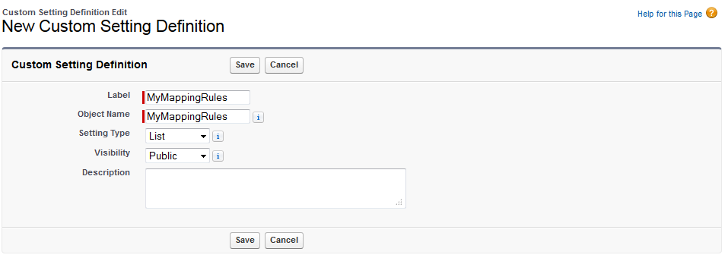
Step Two: Create a new custom field
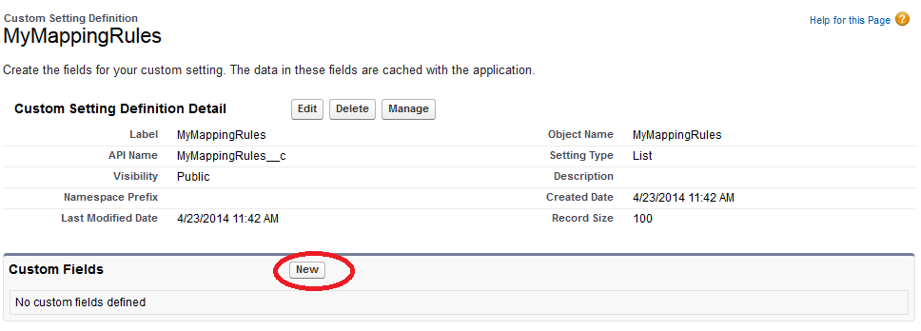
Step Three: Select Text as the field type. The field’s name must be “XPath”
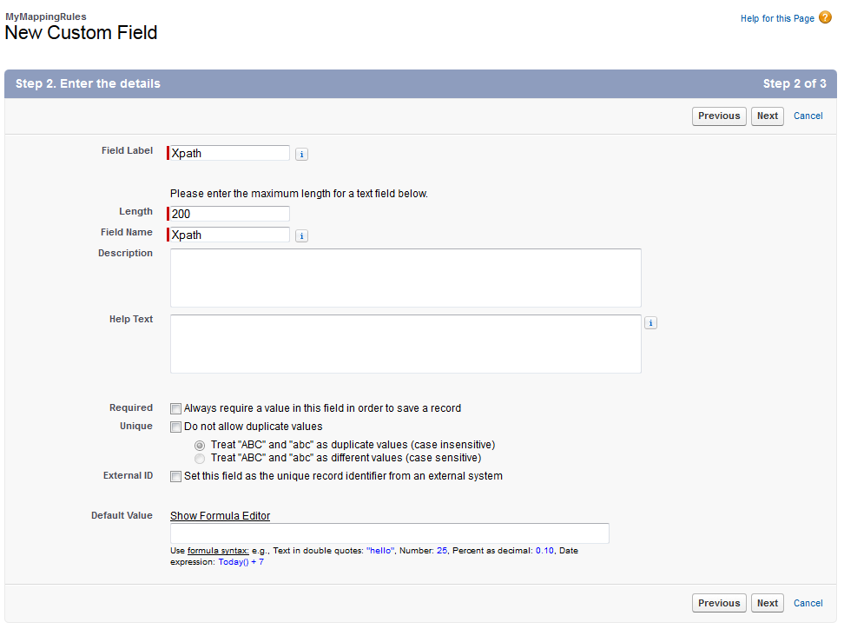
Step Four: After saving the field, you can click on the “manage” button to insert values in this instance.
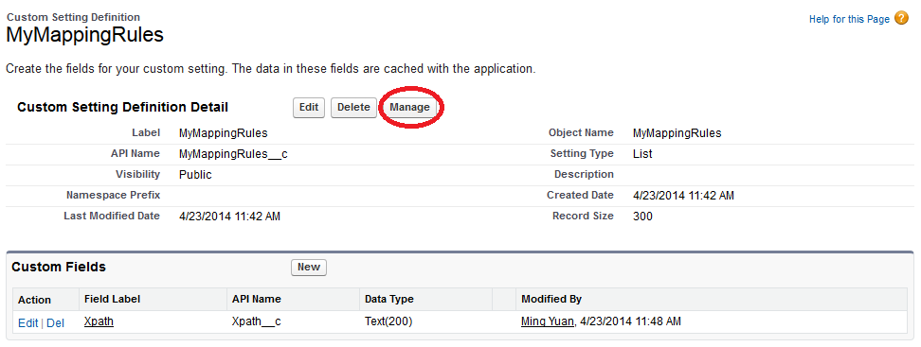
Step Five: Click the new button in next page
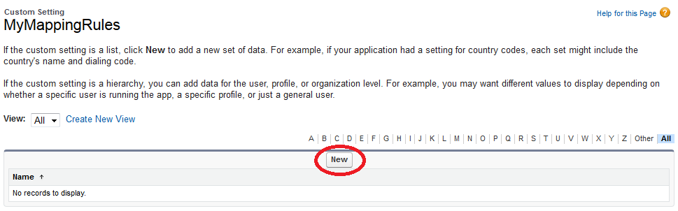
Step Six: In the “name” field, enter the API name for an attribute in SObject; in the Xpath field, enter the Xpath pointing to the corresponding element in XML or JSON message.
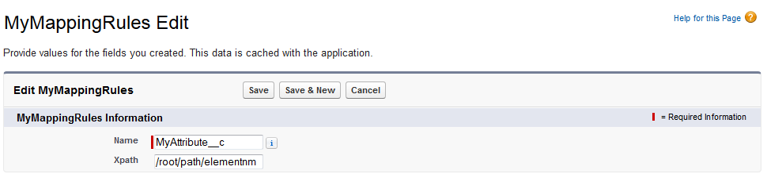
Step Seven: Repeat steps five and six to enter all map rules in one service.
Step Eight: Use the getMappingRules method in the EasySOAHelper class to get a map for these rules.
Map<String, String> myMap = LVT.EasySOAHelper.getMappingRules(‘MyMappingRules’);

respsone.populateFields(new MySobject(), myMap);

            - Both EasyXML and EasyJSON class are accessible to parse XML or JSON, respectively. All the public methods in the EasySOAResponse are also available in these two classes.
            - If a response payload is a JSON Array of other JSON objects, a “rootitem” string will be used as the key for each row of the array. One example is how to define XPath and indexPath to retrieve values from the JSON string below.
[
{
color: "red",
value: "#f00"
},
{
color: "green",
value: "#0f0"
}
]

XPath | IndexPath | Value
“/rootitem/color” | “/0/0” | “red”
“/rootitem/value” | “/0/0” | “#f00”
“/rootitem/color” | “/1/0” | “green”
“/rootitem/value” | “/1/0” | “#0f0”

            - If you’d like to add additional HTTP Headers to your callout request, before calling the “callout” method, you can invoke the “setHTTPHeader” method and pass in a Map<String, String> object.
MySOARequest req = new MySOARequest();
Map<String, String> m = new Map<String, String>();
m.put('mykey', 'myvalue');
req.setHTTPHeaders(m);
LVT.EasySOAResponse resp = req.callout();

Appendix: Full example of consuming a web service

This section has a full working example of invoking a free weather forecast web service hosted at http://wsf.cdyne.com/WeatherWS/Weather.asmx. The operation’s name is “GetCityForecastByZIP”. For more information about this service, you can visit – “http://wsf.cdyne.com/WeatherWS/Weather.asmx?op=GetCityForecastByZIP”. You can also copy and paste the code below into your ORG as a jump start after installing the package.

WebService Request class

global class WeatherRequest extends LVT.EasySOARequest {
public WeatherRequest() {
super();
httpMethod = 'POST';
endpoint = 'http://wsf.cdyne.com/WeatherWS/Weather.asmx';
headers.put('SOAPAction',
‘"http://ws.cdyne.com/WeatherWS/GetCityForecastByZIP"’);
headers.put('Content-Type', 'text/xml; charset=utf-8');
}
public override String getPayload() {
String s = '<GetCityForecastByZIP xmlns=’ +
‘"http://ws.cdyne.com/WeatherWS/">’ +
‘<ZIP>60009</ZIP></GetCityForecastByZIP>';
return getSOAPRequest(s);
}
}

WebService Invoking statements in developer console

WeatherRequest req = new WeatherRequest();
LVT.EasySOAResponse resp = req.callout(true);

if ( !resp.isValid())
System.debug(‘Error happened during invocation.’);

System.debug(resp.getDetails());

Outputs in Logs

12:23:57.354 (354165403)|USER_DEBUG|[6]|DEBUG|
***************** Original Payload for XML Parser ***********************
<?xml version="1.0" encoding="utf-8"?>
<soap:Envelope xmlns:soap="http://schemas.xmlsoap.org/soap/envelope/" xmlns:xsi="http://www.w3.org/2001/XMLSchema-instance"
xmlns:xsd="http://www.w3.org/2001/XMLSchema"><soap:Body>
<GetCityForecastByZIPResponse xmlns="http://ws.cdyne.com/WeatherWS/">
<GetCityForecastByZIPResult>
<Success>true</Success>
<ResponseText>City Found</ResponseText>
<State>IL</State>
<City>Elk Grove Village</City>
<WeatherStationCity>Waukegan</WeatherStationCity>
<ForecastResult>
<Forecast>
<Date>2014-07-10T00:00:00</Date>
<WeatherID>4</WeatherID>
<Desciption>Sunny</Desciption>
<Temperatures>
<MorningLow>56</MorningLow>
<DaytimeHigh>73</DaytimeHigh>
</Temperatures>
<ProbabilityOfPrecipiation>
<Nighttime>00</Nighttime>
<Daytime>00</Daytime>
</ProbabilityOfPrecipiation>
</Forecast>
<Forecast>
<Date>2014-07-11T00:00:00</Date>
<WeatherID>2</WeatherID>
<Desciption>Partly Cloudy</Desciption>
<Temperatures>
<MorningLow>59</MorningLow>
<DaytimeHigh>77</DaytimeHigh>
</Temperatures>
<ProbabilityOfPrecipiation>
<Nighttime>00</Nighttime>
<Daytime>30</Daytime>
</ProbabilityOfPrecipiation>
</Forecast>
<Forecast>
<Date>2014-07-12T00:00:00</Date>
<WeatherID>2</WeatherID>
<Desciption>Partly Cloudy</Desciption>
<Temperatures>
<MorningLow>64</MorningLow>
<DaytimeHigh>80</DaytimeHigh>
</Temperatures>
<ProbabilityOfPrecipiation>
<Nighttime>50</Nighttime>
<Daytime>40</Daytime>
</ProbabilityOfPrecipiation>
</Forecast>
<Forecast>
<Date>2014-07-13T00:00:00</Date>
<WeatherID>2</WeatherID>
<Desciption>Partly Cloudy</Desciption>
<Temperatures>
<MorningLow>66</MorningLow>
<DaytimeHigh>80</DaytimeHigh>
</Temperatures>
<ProbabilityOfPrecipiation>
<Nighttime>50</Nighttime>
<Daytime>40</Daytime>
</ProbabilityOfPrecipiation>
</Forecast>
<Forecast>
<Date>2014-07-14T00:00:00</Date>
<WeatherID>2</WeatherID>
<Desciption>Partly Cloudy</Desciption>
<Temperatures>
<MorningLow>64</MorningLow>
<DaytimeHigh>78</DaytimeHigh>
</Temperatures>
<ProbabilityOfPrecipiation>
<Nighttime>30</Nighttime>
<Daytime>20</Daytime>
</ProbabilityOfPrecipiation>
</Forecast>
<Forecast>
<Date>2014-07-15T00:00:00</Date>
<WeatherID>2</WeatherID>
<Desciption>Partly Cloudy</Desciption>
<Temperatures>
<MorningLow>60</MorningLow>
<DaytimeHigh>71</DaytimeHigh>
</Temperatures>
<ProbabilityOfPrecipiation>
<Nighttime>20</Nighttime>
<Daytime>20</Daytime>
</ProbabilityOfPrecipiation>
</Forecast>
<Forecast>
<Date>2014-07-16T00:00:00</Date>
<WeatherID>2</WeatherID>
<Desciption>Partly Cloudy</Desciption>
<Temperatures>
<MorningLow>57</MorningLow>
<DaytimeHigh>71</DaytimeHigh>
</Temperatures>
<ProbabilityOfPrecipiation>
<Nighttime>10</Nighttime>
<Daytime>20</Daytime>
</ProbabilityOfPrecipiation>
</Forecast>
</ForecastResult>
</GetCityForecastByZIPResult>
</GetCityForecastByZIPResponse>
</soap:Body>
</soap:Envelope>

***************** name/value pairs ****************************

/Envelope/Body/GetCityForecastByZIPResponse/GetCityForecastByZIPResult/City --> Elk Grove Village
/Envelope/Body/GetCityForecastByZIPResponse/GetCityForecastByZIPResult/ForecastResult/Forecast/Date --> 2014-07-10T00:00:00
/Envelope/Body/GetCityForecastByZIPResponse/GetCityForecastByZIPResult/ForecastResult/Forecast/Desciption --> Sunny
/Envelope/Body/GetCityForecastByZIPResponse/GetCityForecastByZIPResult/ForecastResult/Forecast/ProbabilityOfPrecipiation/Daytime --> 00
/Envelope/Body/GetCityForecastByZIPResponse/GetCityForecastByZIPResult/ForecastResult/Forecast/ProbabilityOfPrecipiation/Nighttime --> 00
/Envelope/Body/GetCityForecastByZIPResponse/GetCityForecastByZIPResult/ForecastResult/Forecast/Temperatures/DaytimeHigh --> 73
/Envelope/Body/GetCityForecastByZIPResponse/GetCityForecastByZIPResult/ForecastResult/Forecast/Temperatures/MorningLow --> 56
/Envelope/Body/GetCityForecastByZIPResponse/GetCityForecastByZIPResult/ForecastResult/Forecast/WeatherID --> 4
/Envelope/Body/GetCityForecastByZIPResponse/GetCityForecastByZIPResult/ForecastResult/Forecast/Date [/0/0/0/0/0/1/0] --> 2014-07-11T00:00:00
/Envelope/Body/GetCityForecastByZIPResponse/GetCityForecastByZIPResult/ForecastResult/Forecast/Desciption [/0/0/0/0/0/1/0] --> Partly Cloudy
/Envelope/Body/GetCityForecastByZIPResponse/GetCityForecastByZIPResult/ForecastResult/Forecast/ProbabilityOfPrecipiation/Daytime [/0/0/0/0/0/1/0/0] --> 30
/Envelope/Body/GetCityForecastByZIPResponse/GetCityForecastByZIPResult/ForecastResult/Forecast/ProbabilityOfPrecipiation/Nighttime [/0/0/0/0/0/1/0/0] --> 00
/Envelope/Body/GetCityForecastByZIPResponse/GetCityForecastByZIPResult/ForecastResult/Forecast/Temperatures/DaytimeHigh [/0/0/0/0/0/1/0/0] --> 77
/Envelope/Body/GetCityForecastByZIPResponse/GetCityForecastByZIPResult/ForecastResult/Forecast/Temperatures/MorningLow [/0/0/0/0/0/1/0/0] --> 59
/Envelope/Body/GetCityForecastByZIPResponse/GetCityForecastByZIPResult/ForecastResult/Forecast/WeatherID [/0/0/0/0/0/1/0] --> 2
/Envelope/Body/GetCityForecastByZIPResponse/GetCityForecastByZIPResult/ForecastResult/Forecast/Date [/0/0/0/0/0/2/0] --> 2014-07-12T00:00:00
/Envelope/Body/GetCityForecastByZIPResponse/GetCityForecastByZIPResult/ForecastResult/Forecast/Desciption [/0/0/0/0/0/2/0] --> Partly Cloudy
/Envelope/Body/GetCityForecastByZIPResponse/GetCityForecastByZIPResult/ForecastResult/Forecast/ProbabilityOfPrecipiation/Daytime [/0/0/0/0/0/2/0/0] --> 40
/Envelope/Body/GetCityForecastByZIPResponse/GetCityForecastByZIPResult/ForecastResult/Forecast/ProbabilityOfPrecipiation/Nighttime [/0/0/0/0/0/2/0/0] --> 50
/Envelope/Body/GetCityForecastByZIPResponse/GetCityForecastByZIPResult/ForecastResult/Forecast/Temperatures/DaytimeHigh [/0/0/0/0/0/2/0/0] --> 80
/Envelope/Body/GetCityForecastByZIPResponse/GetCityForecastByZIPResult/ForecastResult/Forecast/Temperatures/MorningLow [/0/0/0/0/0/2/0/0] --> 64
/Envelope/Body/GetCityForecastByZIPResponse/GetCityForecastByZIPResult/ForecastResult/Forecast/WeatherID [/0/0/0/0/0/2/0] --> 2
/Envelope/Body/GetCityForecastByZIPResponse/GetCityForecastByZIPResult/ForecastResult/Forecast/Date [/0/0/0/0/0/3/0] --> 2014-07-13T00:00:00
/Envelope/Body/GetCityForecastByZIPResponse/GetCityForecastByZIPResult/ForecastResult/Forecast/Desciption [/0/0/0/0/0/3/0] --> Partly Cloudy
/Envelope/Body/GetCityForecastByZIPResponse/GetCityForecastByZIPResult/ForecastResult/Forecast/ProbabilityOfPrecipiation/Daytime [/0/0/0/0/0/3/0/0] --> 40
/Envelope/Body/GetCityForecastByZIPResponse/GetCityForecastByZIPResult/ForecastResult/Forecast/ProbabilityOfPrecipiation/Nighttime [/0/0/0/0/0/3/0/0] --> 50
/Envelope/Body/GetCityForecastByZIPResponse/GetCityForecastByZIPResult/ForecastResult/Forecast/Temperatures/DaytimeHigh [/0/0/0/0/0/3/0/0] --> 80
/Envelope/Body/GetCityForecastByZIPResponse/GetCityForecastByZIPResult/ForecastResult/Forecast/Temperatures/MorningLow [/0/0/0/0/0/3/0/0] --> 66
/Envelope/Body/GetCityForecastByZIPResponse/GetCityForecastByZIPResult/ForecastResult/Forecast/WeatherID [/0/0/0/0/0/3/0] --> 2
/Envelope/Body/GetCityForecastByZIPResponse/GetCityForecastByZIPResult/ForecastResult/Forecast/Date [/0/0/0/0/0/4/0] --> 2014-07-14T00:00:00
/Envelope/Body/GetCityForecastByZIPResponse/GetCityForecastByZIPResult/ForecastResult/Forecast/Desciption [/0/0/0/0/0/4/0] --> Partly Cloudy
/Envelope/Body/GetCityForecastByZIPResponse/GetCityForecastByZIPResult/ForecastResult/Forecast/ProbabilityOfPrecipiation/Daytime [/0/0/0/0/0/4/0/0] --> 20
/Envelope/Body/GetCityForecastByZIPResponse/GetCityForecastByZIPResult/ForecastResult/Forecast/ProbabilityOfPrecipiation/Nighttime [/0/0/0/0/0/4/0/0] --> 30
/Envelope/Body/GetCityForecastByZIPResponse/GetCityForecastByZIPResult/ForecastResult/Forecast/Temperatures/DaytimeHigh [/0/0/0/0/0/4/0/0] --> 78
/Envelope/Body/GetCityForecastByZIPResponse/GetCityForecastByZIPResult/ForecastResult/Forecast/Temperatures/MorningLow [/0/0/0/0/0/4/0/0] --> 64
/Envelope/Body/GetCityForecastByZIPResponse/GetCityForecastByZIPResult/ForecastResult/Forecast/WeatherID [/0/0/0/0/0/4/0] --> 2
/Envelope/Body/GetCityForecastByZIPResponse/GetCityForecastByZIPResult/ForecastResult/Forecast/Date [/0/0/0/0/0/5/0] --> 2014-07-15T00:00:00
/Envelope/Body/GetCityForecastByZIPResponse/GetCityForecastByZIPResult/ForecastResult/Forecast/Desciption [/0/0/0/0/0/5/0] --> Partly Cloudy
/Envelope/Body/GetCityForecastByZIPResponse/GetCityForecastByZIPResult/ForecastResult/Forecast/ProbabilityOfPrecipiation/Daytime [/0/0/0/0/0/5/0/0] --> 20
/Envelope/Body/GetCityForecastByZIPResponse/GetCityForecastByZIPResult/ForecastResult/Forecast/ProbabilityOfPrecipiation/Nighttime [/0/0/0/0/0/5/0/0] --> 20
/Envelope/Body/GetCityForecastByZIPResponse/GetCityForecastByZIPResult/ForecastResult/Forecast/Temperatures/DaytimeHigh [/0/0/0/0/0/5/0/0] --> 71
/Envelope/Body/GetCityForecastByZIPResponse/GetCityForecastByZIPResult/ForecastResult/Forecast/Temperatures/MorningLow [/0/0/0/0/0/5/0/0] --> 60
/Envelope/Body/GetCityForecastByZIPResponse/GetCityForecastByZIPResult/ForecastResult/Forecast/WeatherID [/0/0/0/0/0/5/0] --> 2
/Envelope/Body/GetCityForecastByZIPResponse/GetCityForecastByZIPResult/ForecastResult/Forecast/Date [/0/0/0/0/0/6/0] --> 2014-07-16T00:00:00
/Envelope/Body/GetCityForecastByZIPResponse/GetCityForecastByZIPResult/ForecastResult/Forecast/Desciption [/0/0/0/0/0/6/0] --> Partly Cloudy
/Envelope/Body/GetCityForecastByZIPResponse/GetCityForecastByZIPResult/ForecastResult/Forecast/ProbabilityOfPrecipiation/Daytime [/0/0/0/0/0/6/0/0] --> 20
/Envelope/Body/GetCityForecastByZIPResponse/GetCityForecastByZIPResult/ForecastResult/Forecast/ProbabilityOfPrecipiation/Nighttime [/0/0/0/0/0/6/0/0] --> 10
/Envelope/Body/GetCityForecastByZIPResponse/GetCityForecastByZIPResult/ForecastResult/Forecast/Temperatures/DaytimeHigh [/0/0/0/0/0/6/0/0] --> 71
/Envelope/Body/GetCityForecastByZIPResponse/GetCityForecastByZIPResult/ForecastResult/Forecast/Temperatures/MorningLow [/0/0/0/0/0/6/0/0] --> 57
/Envelope/Body/GetCityForecastByZIPResponse/GetCityForecastByZIPResult/ForecastResult/Forecast/WeatherID [/0/0/0/0/0/6/0] --> 2
/Envelope/Body/GetCityForecastByZIPResponse/GetCityForecastByZIPResult/ResponseText --> City Found
/Envelope/Body/GetCityForecastByZIPResponse/GetCityForecastByZIPResult/State --> IL
/Envelope/Body/GetCityForecastByZIPResponse/GetCityForecastByZIPResult/Success --> true
/Envelope/Body/GetCityForecastByZIPResponse/GetCityForecastByZIPResult/WeatherStationCity --> Waukegan
***************** number of occurrence ****************************

/Envelope --> 1
/Envelope/Body --> 1
/Envelope/Body/GetCityForecastByZIPResponse --> 1
/Envelope/Body/GetCityForecastByZIPResponse/GetCityForecastByZIPResult --> 1
/Envelope/Body/GetCityForecastByZIPResponse/GetCityForecastByZIPResult/City --> 1
/Envelope/Body/GetCityForecastByZIPResponse/GetCityForecastByZIPResult/ForecastResult --> 1
/Envelope/Body/GetCityForecastByZIPResponse/GetCityForecastByZIPResult/ForecastResult/Forecast --> 7
/Envelope/Body/GetCityForecastByZIPResponse/GetCityForecastByZIPResult/ForecastResult/Forecast/Date --> 1
/Envelope/Body/GetCityForecastByZIPResponse/GetCityForecastByZIPResult/ForecastResult/Forecast/Desciption --> 1
/Envelope/Body/GetCityForecastByZIPResponse/GetCityForecastByZIPResult/ForecastResult/Forecast/ProbabilityOfPrecipiation --> 1
/Envelope/Body/GetCityForecastByZIPResponse/GetCityForecastByZIPResult/ForecastResult/Forecast/ProbabilityOfPrecipiation/Daytime --> 1
/Envelope/Body/GetCityForecastByZIPResponse/GetCityForecastByZIPResult/ForecastResult/Forecast/ProbabilityOfPrecipiation/Nighttime --> 1
/Envelope/Body/GetCityForecastByZIPResponse/GetCityForecastByZIPResult/ForecastResult/Forecast/Temperatures --> 1
/Envelope/Body/GetCityForecastByZIPResponse/GetCityForecastByZIPResult/ForecastResult/Forecast/Temperatures/DaytimeHigh --> 1
/Envelope/Body/GetCityForecastByZIPResponse/GetCityForecastByZIPResult/ForecastResult/Forecast/Temperatures/MorningLow --> 1
/Envelope/Body/GetCityForecastByZIPResponse/GetCityForecastByZIPResult/ForecastResult/Forecast/WeatherID --> 1
/Envelope/Body/GetCityForecastByZIPResponse/GetCityForecastByZIPResult/ForecastResult/Forecast/Date [/0/0/0/0/0/1/0] --> 1
/Envelope/Body/GetCityForecastByZIPResponse/GetCityForecastByZIPResult/ForecastResult/Forecast/Desciption [/0/0/0/0/0/1/0] --> 1
/Envelope/Body/GetCityForecastByZIPResponse/GetCityForecastByZIPResult/ForecastResult/Forecast/ProbabilityOfPrecipiation [/0/0/0/0/0/1/0] --> 1
/Envelope/Body/GetCityForecastByZIPResponse/GetCityForecastByZIPResult/ForecastResult/Forecast/ProbabilityOfPrecipiation/Daytime [/0/0/0/0/0/1/0/0] --> 1
/Envelope/Body/GetCityForecastByZIPResponse/GetCityForecastByZIPResult/ForecastResult/Forecast/ProbabilityOfPrecipiation/Nighttime [/0/0/0/0/0/1/0/0] --> 1
/Envelope/Body/GetCityForecastByZIPResponse/GetCityForecastByZIPResult/ForecastResult/Forecast/Temperatures [/0/0/0/0/0/1/0] --> 1
/Envelope/Body/GetCityForecastByZIPResponse/GetCityForecastByZIPResult/ForecastResult/Forecast/Temperatures/DaytimeHigh [/0/0/0/0/0/1/0/0] --> 1
/Envelope/Body/GetCityForecastByZIPResponse/GetCityForecastByZIPResult/ForecastResult/Forecast/Temperatures/MorningLow [/0/0/0/0/0/1/0/0] --> 1
/Envelope/Body/GetCityForecastByZIPResponse/GetCityForecastByZIPResult/ForecastResult/Forecast/WeatherID [/0/0/0/0/0/1/0] --> 1
/Envelope/Body/GetCityForecastByZIPResponse/GetCityForecastByZIPResult/ForecastResult/Forecast/Date [/0/0/0/0/0/2/0] --> 1
/Envelope/Body/GetCityForecastByZIPResponse/GetCityForecastByZIPResult/ForecastResult/Forecast/Desciption [/0/0/0/0/0/2/0] --> 1
/Envelope/Body/GetCityForecastByZIPResponse/GetCityForecastByZIPResult/ForecastResult/Forecast/ProbabilityOfPrecipiation [/0/0/0/0/0/2/0] --> 1
/Envelope/Body/GetCityForecastByZIPResponse/GetCityForecastByZIPResult/ForecastResult/Forecast/ProbabilityOfPrecipiation/Daytime [/0/0/0/0/0/2/0/0] --> 1
/Envelope/Body/GetCityForecastByZIPResponse/GetCityForecastByZIPResult/ForecastResult/Forecast/ProbabilityOfPrecipiation/Nighttime [/0/0/0/0/0/2/0/0] --> 1
/Envelope/Body/GetCityForecastByZIPResponse/GetCityForecastByZIPResult/ForecastResult/Forecast/Temperatures [/0/0/0/0/0/2/0] --> 1
/Envelope/Body/GetCityForecastByZIPResponse/GetCityForecastByZIPResult/ForecastResult/Forecast/Temperatures/DaytimeHigh [/0/0/0/0/0/2/0/0] --> 1
/Envelope/Body/GetCityForecastByZIPResponse/GetCityForecastByZIPResult/ForecastResult/Forecast/Temperatures/MorningLow [/0/0/0/0/0/2/0/0] --> 1
/Envelope/Body/GetCityForecastByZIPResponse/GetCityForecastByZIPResult/ForecastResult/Forecast/WeatherID [/0/0/0/0/0/2/0] --> 1
/Envelope/Body/GetCityForecastByZIPResponse/GetCityForecastByZIPResult/ForecastResult/Forecast/Date [/0/0/0/0/0/3/0] --> 1
/Envelope/Body/GetCityForecastByZIPResponse/GetCityForecastByZIPResult/ForecastResult/Forecast/Desciption [/0/0/0/0/0/3/0] --> 1
/Envelope/Body/GetCityForecastByZIPResponse/GetCityForecastByZIPResult/ForecastResult/Forecast/ProbabilityOfPrecipiation [/0/0/0/0/0/3/0] --> 1
/Envelope/Body/GetCityForecastByZIPResponse/GetCityForecastByZIPResult/ForecastResult/Forecast/ProbabilityOfPrecipiation/Daytime [/0/0/0/0/0/3/0/0] --> 1
/Envelope/Body/GetCityForecastByZIPResponse/GetCityForecastByZIPResult/ForecastResult/Forecast/ProbabilityOfPrecipiation/Nighttime [/0/0/0/0/0/3/0/0] --> 1
/Envelope/Body/GetCityForecastByZIPResponse/GetCityForecastByZIPResult/ForecastResult/Forecast/Temperatures [/0/0/0/0/0/3/0] --> 1
/Envelope/Body/GetCityForecastByZIPResponse/GetCityForecastByZIPResult/ForecastResult/Forecast/Temperatures/DaytimeHigh [/0/0/0/0/0/3/0/0] --> 1
/Envelope/Body/GetCityForecastByZIPResponse/GetCityForecastByZIPResult/ForecastResult/Forecast/Temperatures/MorningLow [/0/0/0/0/0/3/0/0] --> 1
/Envelope/Body/GetCityForecastByZIPResponse/GetCityForecastByZIPResult/ForecastResult/Forecast/WeatherID [/0/0/0/0/0/3/0] --> 1
/Envelope/Body/GetCityForecastByZIPResponse/GetCityForecastByZIPResult/ForecastResult/Forecast/Date [/0/0/0/0/0/4/0] --> 1
/Envelope/Body/GetCityForecastByZIPResponse/GetCityForecastByZIPResult/ForecastResult/Forecast/Desciption [/0/0/0/0/0/4/0] --> 1
/Envelope/Body/GetCityForecastByZIPResponse/GetCityForecastByZIPResult/ForecastResult/Forecast/ProbabilityOfPrecipiation [/0/0/0/0/0/4/0] --> 1
/Envelope/Body/GetCityForecastByZIPResponse/GetCityForecastByZIPResult/ForecastResult/Forecast/ProbabilityOfPrecipiation/Daytime [/0/0/0/0/0/4/0/0] --> 1
/Envelope/Body/GetCityForecastByZIPResponse/GetCityForecastByZIPResult/ForecastResult/Forecast/ProbabilityOfPrecipiation/Nighttime [/0/0/0/0/0/4/0/0] --> 1
/Envelope/Body/GetCityForecastByZIPResponse/GetCityForecastByZIPResult/ForecastResult/Forecast/Temperatures [/0/0/0/0/0/4/0] --> 1
/Envelope/Body/GetCityForecastByZIPResponse/GetCityForecastByZIPResult/ForecastResult/Forecast/Temperatures/DaytimeHigh [/0/0/0/0/0/4/0/0] --> 1
/Envelope/Body/GetCityForecastByZIPResponse/GetCityForecastByZIPResult/ForecastResult/Forecast/Temperatures/MorningLow [/0/0/0/0/0/4/0/0] --> 1
/Envelope/Body/GetCityForecastByZIPResponse/GetCityForecastByZIPResult/ForecastResult/Forecast/WeatherID [/0/0/0/0/0/4/0] --> 1
/Envelope/Body/GetCityForecastByZIPResponse/GetCityForecastByZIPResult/ForecastResult/Forecast/Date [/0/0/0/0/0/5/0] --> 1
/Envelope/Body/GetCityForecastByZIPResponse/GetCityForecastByZIPResult/ForecastResult/Forecast/Desciption [/0/0/0/0/0/5/0] --> 1
/Envelope/Body/GetCityForecastByZIPResponse/GetCityForecastByZIPResult/ForecastResult/Forecast/ProbabilityOfPrecipiation [/0/0/0/0/0/5/0] --> 1
/Envelope/Body/GetCityForecastByZIPResponse/GetCityForecastByZIPResult/ForecastResult/Forecast/ProbabilityOfPrecipiation/Daytime [/0/0/0/0/0/5/0/0] --> 1
/Envelope/Body/GetCityForecastByZIPResponse/GetCityForecastByZIPResult/ForecastResult/Forecast/ProbabilityOfPrecipiation/Nighttime [/0/0/0/0/0/5/0/0] --> 1
/Envelope/Body/GetCityForecastByZIPResponse/GetCityForecastByZIPResult/ForecastResult/Forecast/Temperatures [/0/0/0/0/0/5/0] --> 1
/Envelope/Body/GetCityForecastByZIPResponse/GetCityForecastByZIPResult/ForecastResult/Forecast/Temperatures/DaytimeHigh [/0/0/0/0/0/5/0/0] --> 1
/Envelope/Body/GetCityForecastByZIPResponse/GetCityForecastByZIPResult/ForecastResult/Forecast/Temperatures/MorningLow [/0/0/0/0/0/5/0/0] --> 1
/Envelope/Body/GetCityForecastByZIPResponse/GetCityForecastByZIPResult/ForecastResult/Forecast/WeatherID [/0/0/0/0/0/5/0] --> 1
/Envelope/Body/GetCityForecastByZIPResponse/GetCityForecastByZIPResult/ForecastResult/Forecast/Date [/0/0/0/0/0/6/0] --> 1
/Envelope/Body/GetCityForecastByZIPResponse/GetCityForecastByZIPResult/ForecastResult/Forecast/Desciption [/0/0/0/0/0/6/0] --> 1
/Envelope/Body/GetCityForecastByZIPResponse/GetCityForecastByZIPResult/ForecastResult/Forecast/ProbabilityOfPrecipiation [/0/0/0/0/0/6/0] --> 1
/Envelope/Body/GetCityForecastByZIPResponse/GetCityForecastByZIPResult/ForecastResult/Forecast/ProbabilityOfPrecipiation/Daytime [/0/0/0/0/0/6/0/0] --> 1
/Envelope/Body/GetCityForecastByZIPResponse/GetCityForecastByZIPResult/ForecastResult/Forecast/ProbabilityOfPrecipiation/Nighttime [/0/0/0/0/0/6/0/0] --> 1
/Envelope/Body/GetCityForecastByZIPResponse/GetCityForecastByZIPResult/ForecastResult/Forecast/Temperatures [/0/0/0/0/0/6/0] --> 1
/Envelope/Body/GetCityForecastByZIPResponse/GetCityForecastByZIPResult/ForecastResult/Forecast/Temperatures/DaytimeHigh [/0/0/0/0/0/6/0/0] --> 1
/Envelope/Body/GetCityForecastByZIPResponse/GetCityForecastByZIPResult/ForecastResult/Forecast/Temperatures/MorningLow [/0/0/0/0/0/6/0/0] --> 1
/Envelope/Body/GetCityForecastByZIPResponse/GetCityForecastByZIPResult/ForecastResult/Forecast/WeatherID [/0/0/0/0/0/6/0] --> 1
/Envelope/Body/GetCityForecastByZIPResponse/GetCityForecastByZIPResult/ResponseText --> 1
/Envelope/Body/GetCityForecastByZIPResponse/GetCityForecastByZIPResult/State --> 1
/Envelope/Body/GetCityForecastByZIPResponse/GetCityForecastByZIPResult/Success --> 1
/Envelope/Body/GetCityForecastByZIPResponse/GetCityForecastByZIPResult/WeatherStationCity --> 1
*********************************************

